APPENDIX

# Load and Analyze Data

[1]: **import pandas as pd import numpy as np**

**import matplotlib.pyplot as plt import seaborn as sns**

**import missingno as msno from scipy import** stats **import sklearn**

**import statsmodels**

**import statsmodels.api as sm**

**import statsmodels.formula.api as smf**

**from sklearn.metrics import** mean_squared_error **from sklearn.metrics import** mean_absolute_error **from sklearn.metrics import** r2_score

**from sklearn.model_selection import** train_test_split **from sklearn.preprocessing import** StandardScaler **from sklearn.neighbors import** KNeighborsRegressor **from sklearn.decomposition import** PCA

### import random

**from sklearn.model_selection import** cross_val_score

### from sklearn.model_selection import KFold

**from sklearn.model_selection import** GridSearchCV

**from sklearn.metrics import** make_scorer **from sklearn.pipeline import** Pipeline **from numpy import** mean

### from numpy import std

**from sklearn.linear_model import** SGDRegressor

### from sklearn.linear_model import Ridge

**from sklearn.preprocessing import** PolynomialFeatures

### from sklearn.linear_model import Lasso

**from sklearn.linear_model import** ElasticNet

**from sklearn.ensemble import** RandomForestRegressor

**import umap**

**import tensorflow as tf**

**from tensorflow.keras import** Model

**from tensorflow.keras import** Sequential

**from tensorflow.keras.optimizers import** Adam

**from sklearn.preprocessing import** StandardScaler **from tensorflow.keras.layers import** Dense, Dropout **from sklearn.model_selection import** train_test_split

**from tensorflow.keras.losses import** MeanSquaredLogarithmicError

**from sklearn.metrics import** mean_squared_error

**from keras.callbacks import** ModelCheckpoint

**from statsmodels.stats.outliers_influence import** variance_inflation_factor

**from sklearn.manifold import** TSNE

**from statsmodels.tools.tools import** maybe_unwrap_results

**from statsmodels.graphics.gofplots import** ProbPlot

**from statsmodels.stats.outliers_influence import** variance_inflation_factor

**from typing import** Type

style_talk = 'seaborn-talk' *#refer to plt.style.available*

random.seed(101) np.random.seed(101)

%**matplotlib** inline

[2]:

**class Linear_Reg_Diagnostic**():

*"""*

*Diagnostic plots to identify potential problems in a linear regression fit. Mainly,*

1. *non-linearity of data*
2. *Correlation of error terms*
3. *non-constant variance*
4. *outliers*
5. *high-leverage points*
6. *collinearity*

*"""*

**def**  init (self,

results: Type[statsmodels.regression.linear_model.

*'→*RegressionResultsWrapper]) -> **None**:

*"""*

*For a linear regression model, generates following diagnostic plots:*

1. *residual*
2. *qq*
3. *scale location and*
4. *leverage and a table*
5. *vif*

*Args:*

*results (Type[statsmodels.regression.linear_model.*

*'→RegressionResultsWrapper]):*

*must be instance of statsmodels.regression.linear_model object*

*Raises:*

*TypeError: if instance does not belong to above object*

*Example:*

*>>> import numpy as np*

*>>> import pandas as pd*

*>>> import statsmodels.formula.api as smf*

*>>> x = np.linspace(-np.pi, np.pi, 100)*

*>>> y = 3*x + 8 + np.random.normal(0,1, 100)*

*>>> df = pd.DataFrame({'x':x, 'y':y})*

*>>> res = smf.ols(formula= "y ~ x", data=df).fit()*

*>>> cls = Linear_Reg_Diagnostic(res)*

*>>> cls(plot_context="seaborn-paper")*

*In case you do not need all plots you can also independently make an*␣

*'→individual plot/table*

*in following ways*

*>>> cls = Linear_Reg_Diagnostic(res)*

*>>> cls.residual_plot()*

*>>> cls.qq_plot()*

*>>> cls.scale_location_plot()*

*>>> cls.leverage_plot()*

*>>> cls.vif_table() """*

**if** isinstance(results, statsmodels.regression.linear_model.

*'→*RegressionResultsWrapper) **is False**:

**raise TypeError**("result must be instance of statsmodels.regression.

*'→*linear_model.RegressionResultsWrapper object")

self.results = maybe_unwrap_results(results)

self.y_true = self.results.model.endog self.y_predict = self.results.fittedvalues self.xvar = self.results.model.exog self.xvar_names = self.results.model.exog_names

self.residual = np.array(self.results.resid) influence = self.results.get_influence()

self.residual_norm = influence.resid_studentized_internal self.leverage = influence.hat_matrix_diag self.cooks_distance = influence.cooks_distance[0]

### def

self.nparams = len(self.results.params)

call (self, plot_context='seaborn-paper'):

*# print(plt.style.available)*

**with** plt.style.context(plot_context):

fig, ax = plt.subplots(nrows=2, ncols=2, figsize=(10,10)) self.residual_plot(ax=ax[0,0])

self.qq_plot(ax=ax[0,1]) self.scale_location_plot(ax=ax[1,0]) self.leverage_plot(ax=ax[1,1]) plt.show()

self.vif_table()

**return** fig, ax

**def** residual_plot(self, ax=**None**):

*"""*

*Residual vs Fitted Plot*

*Graphical tool to identify non-linearity.*

*(Roughly) Horizontal red line is an indicator that the residual has a*␣

*'→linear pattern*

*"""*

**if** ax **is None**:

fig, ax = plt.subplots()

sns.residplot( x=self.y_predict, y=self.residual, lowess=**True**, scatter_kws={'alpha': 0.5},

line_kws={'color': 'red', 'lw': 1, 'alpha': 0.8}, ax=ax)

*# annotations*

residual_abs = np.abs(self.residual) abs_resid = np.flip(np.sort(residual_abs)) abs_resid_top_3 = abs_resid[:3]

**for** i, _ **in** enumerate(abs_resid_top_3): ax.annotate(

i,

xy=(self.y_predict[i], self.residual[i]), color='C3')

ax.set_title('Residuals vs Fitted', fontweight="bold") ax.set_xlabel('Fitted values')

ax.set_ylabel('Residuals')

### return ax

**def** qq_plot(self, ax=**None**):

*"""*

*Standarized Residual vs Theoretical Quantile plot*

*Used to visually check if residuals are normally distributed. Points spread along the diagonal line will suggest so.*

*"""*

**if** ax **is None**:

fig, ax = plt.subplots()

QQ = ProbPlot(self.residual_norm) QQ.qqplot(line='45', alpha=0.5, lw=1, ax=ax)

*# annotations*

abs_norm_resid = np.flip(np.argsort(np.abs(self.residual_norm)), 0) abs_norm_resid_top_3 = abs_norm_resid[:3]

**for** r, i **in** enumerate(abs_norm_resid_top_3): ax.annotate(

i,

xy=(np.flip(QQ.theoretical_quantiles, 0)[r], self.

*'→*residual_norm[i]),

ha='right', color='C3')

ax.set_title('Normal Q-Q', fontweight="bold") ax.set_xlabel('Theoretical Quantiles') ax.set_ylabel('Standardized Residuals') **return** ax

**def** scale_location_plot(self, ax=**None**):

*"""*

*Sqrt(Standarized Residual) vs Fitted values plot*

*Used to check homoscedasticity of the residuals. Horizontal line will suggest so.*

*"""*

**if** ax **is None**:

fig, ax = plt.subplots()

residual_norm_abs_sqrt = np.sqrt(np.abs(self.residual_norm))

ax.scatter(self.y_predict, residual_norm_abs_sqrt, alpha=0.5); sns.regplot(

x=self.y_predict, y=residual_norm_abs_sqrt,

scatter=**False**, ci=**False**, lowess=**True**,

line_kws={'color': 'red', 'lw': 1, 'alpha': 0.8}, ax=ax)

*# annotations*

abs_sq_norm_resid = np.flip(np.argsort(residual_norm_abs_sqrt), 0) abs_sq_norm_resid_top_3 = abs_sq_norm_resid[:3]

**for** i **in** abs_sq_norm_resid_top_3: ax.annotate(

i,

xy=(self.y_predict[i], residual_norm_abs_sqrt[i]), color='C3')

ax.set_title('Scale-Location', fontweight="bold") ax.set_xlabel('Fitted values') ax.set_ylabel(r'$\sqrt{|\mathrm{Standardized\ Residuals}|}$'); **return** ax

**def** leverage_plot(self, ax=**None**):

*"""*

*Residual vs Leverage plot*

*Points falling outside Cook's distance curves are considered*␣

*'→observation that can sway the fit*

*aka are influential.*

*Good to have none outside the curves. """*

**if** ax **is None**:

fig, ax = plt.subplots()

ax.scatter(

self.leverage, self.residual_norm, alpha=0.5);

sns.regplot(

x=self.leverage, y=self.residual_norm, scatter=**False**, ci=**False**, lowess=**True**,

line_kws={'color': 'red', 'lw': 1, 'alpha': 0.8}, ax=ax)

*# annotations*

leverage_top_3 = np.flip(np.argsort(self.cooks_distance), 0)[:3]

**for** i **in** leverage_top_3:

ax.annotate(

i,

xy=(self.leverage[i], self.residual_norm[i]), color = 'C3')

xtemp, ytemp = self. cooks_dist_line(0.5) *# 0.5 line*

ax.plot(xtemp, ytemp, label="Cook's distance", lw=1, ls='--',␣

*'→*color='red')

xtemp, ytemp = self. cooks_dist_line(1) *# 1 line*

ax.plot(xtemp, ytemp, lw=1, ls='--', color='red')

ax.set_xlim(0, max(self.leverage)+0.01) ax.set_title('Residuals vs Leverage', fontweight="bold") ax.set_xlabel('Leverage')

ax.set_ylabel('Standardized Residuals') ax.legend(loc='upper right')

### return ax

**def** vif_table(self):

*"""*

*VIF table*

*VIF, the variance inflation factor, is a measure of multicollinearity. VIF > 5 for a variable indicates that it is highly collinear with the other input variables.*

*"""*

vif_df = pd.DataFrame() vif_df["Features"] = self.xvar_names

vif_df["VIF Factor"] = [variance_inflation_factor(self.xvar, i) **for** i␣

*'→***in** range(self.xvar.shape[1])]

print(vif_df

.sort_values("VIF Factor")

.round(2))

### def

cooks_dist_line(self, factor):

*"""*

*Helper function for plotting Cook's distance curves """*

p = self.nparams

formula = **lambda** x: np.sqrt((factor * p * (1 - x)) / x) x = np.linspace(0.001, max(self.leverage), 50)

y = formula(x)

**return** x, y

[3]:

df = pd.read_csv("qsar_fish_toxicity.csv", delimiter = ";", names = ["CIC0",␣

*'→*"SM1_Dz", "GATS1i", "NdsCH", "NdssC", "MLOGP", "LC50"])

df.shape

[3]: (908, 7)

[4]:

df.head()

1. : CIC0 SM1_Dz GATS1i NdsCH NdssC MLOGP LC50

|  |  |  |
| --- | --- | --- |
| 0 3.260 0.829 1.676 | 0 | 1 1.453 3.770 |
| 1 2.189 0.580 0.863 | 0 | 0 1.348 3.115 |
| 2 2.125 0.638 0.831 | 0 | 0 1.348 3.531 |
| 3 3.027 0.331 1.472 | 1 | 0 1.807 3.510 |
| 4 2.094 0.827 0.860 | 0 | 0 1.886 5.390 |

[5]:

df.tail()

1. : CIC0 SM1_Dz GATS1i NdsCH NdssC MLOGP LC50

|  |  |  |
| --- | --- | --- |
| 903 2.801 0.728 2.226 | 0 | 2 0.736 3.109 |
| 904 3.652 0.872 0.867 | 2 | 3 3.983 4.040 |
| 905 3.763 0.916 0.878 | 0 | 6 2.918 4.818 |
| 906 2.831 1.393 1.077 | 0 | 1 0.906 5.317 |
| 907 4.057 1.032 1.183 | 1 | 3 4.754 8.201 |

[6]:

df.describe()

|  |  |  |  |  |  |  |  |
| --- | --- | --- | --- | --- | --- | --- | --- |
| [6]: | CIC0 | SM1_Dz | GATS1i | NdsCH | NdssC | MLOGP | \ |
| count | 908.000000 | 908.000000 | 908.000000 | 908.000000 | 908.000000 | 908.000000 |  |
| mean | 2.898129 | 0.628468 | 1.293591 | 0.229075 | 0.485683 | 2.109285 |  |
| std | 0.756088 | 0.428459 | 0.394303 | 0.605335 | 0.861279 | 1.433181 |  |
| min | 0.667000 | 0.000000 | 0.396000 | 0.000000 | 0.000000 | -2.884000 |  |
| 25% | 2.347000 | 0.223000 | 0.950750 | 0.000000 | 0.000000 | 1.209000 |  |
| 50% | 2.934000 | 0.570000 | 1.240500 | 0.000000 | 0.000000 | 2.127000 |  |
| 75% | 3.407000 | 0.892750 | 1.562250 | 0.000000 | 1.000000 | 3.105000 |  |
| max | 5.926000 | 2.171000 | 2.920000 | 4.000000 | 6.000000 | 6.515000 |  |
| count | LC50 908.000000 |  |  |  |  |  |  |
| mean | 4.064431 |  |  |  |  |  |  |
| std | 1.455698 |  |  |  |  |  |  |
| min | 0.053000 |  |  |  |  |  |  |
| 25% | 3.151750 |  |  |  |  |  |  |
| 50% | 3.987500 |  |  |  |  |  |  |
| 75% | 4.907500 |  |  |  |  |  |  |
| max | 9.612000 |  |  |  |  |  |  |

[7]:

msno.bar(df, figsize=(10,5), fontsize=12)

1. : <AxesSubplot:>

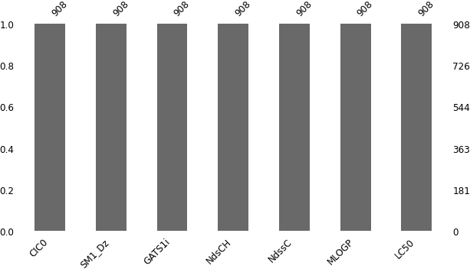

[8]:

sns.pairplot(df)

1. : <seaborn.axisgrid.PairGrid at 0x29ef9575550>

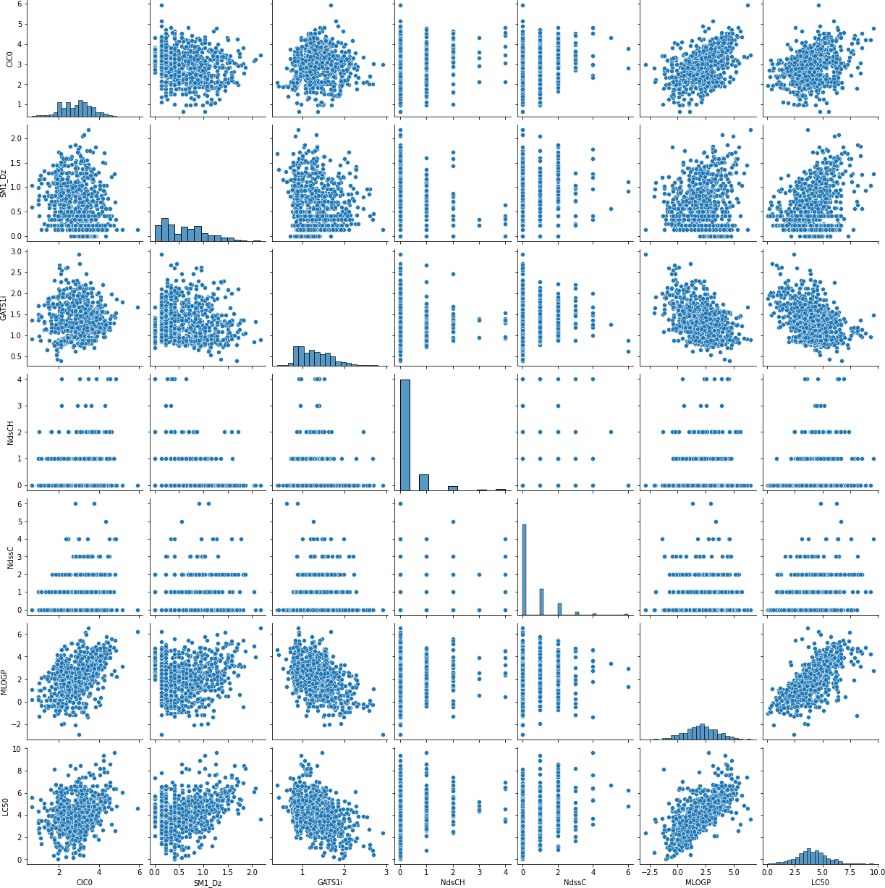

[9]:

plt.figure(figsize = (10,10))

plot = plt.scatter(df["CIC0"], df["LC50"]) plt.xlabel("CICO")

plt.ylabel("LC50") plt.title("CIC0 vs LC50") plt.show()

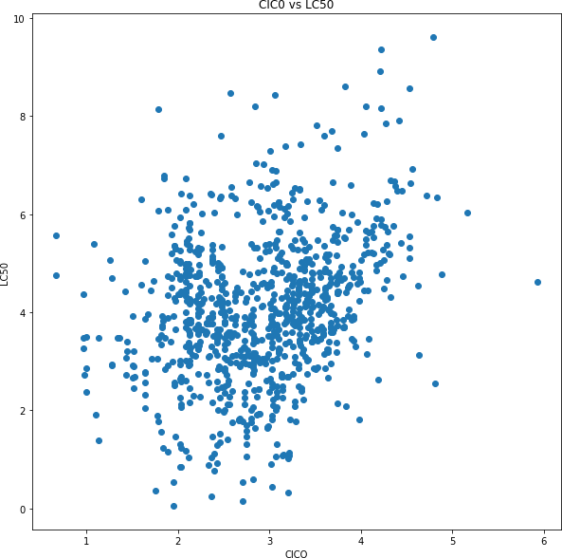

[10]:

plt.figure(figsize = (10,10))

plot = plt.scatter(df["MLOGP"], df["LC50"]) plt.xlabel("MLOGP")

plt.ylabel("LC50") plt.title("MLOGP vs LC50") plt.show()

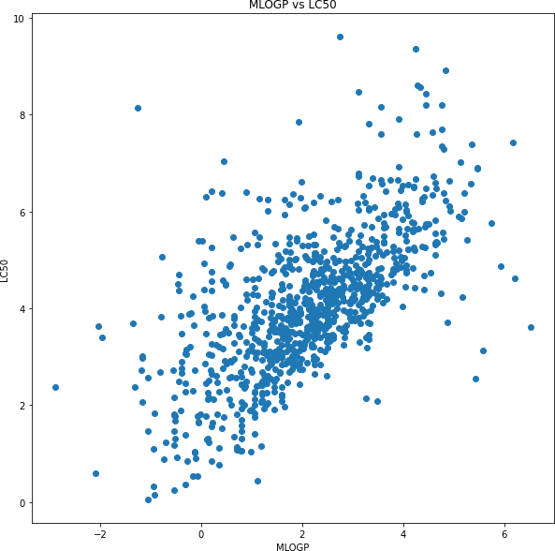

[11]:

plt.figure(figsize = (10,10))

plot = plt.scatter(df["SM1_Dz"], df["LC50"]) plt.xlabel("SM1_Dz")

plt.ylabel("LC50") plt.title("SM1_Dz vs LC50") plt.show()

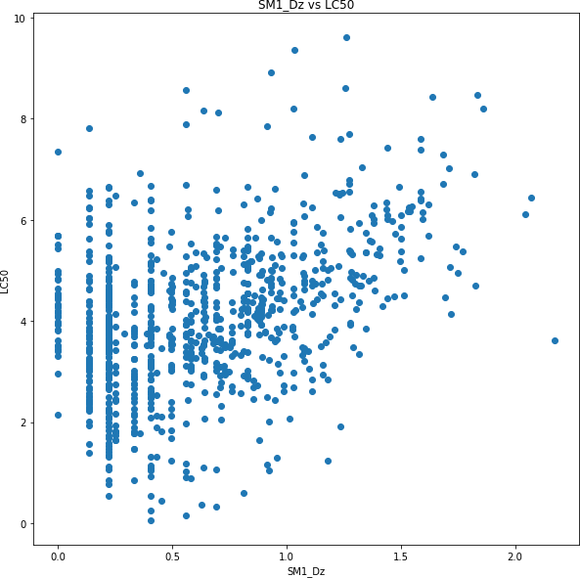

[12]:

plt.figure(figsize = (10,10))

plot = plt.scatter(df["GATS1i"], df["LC50"]) plt.xlabel("GATS1i")

plt.ylabel("LC50") plt.title("GATS1i vs LC50") plt.show()

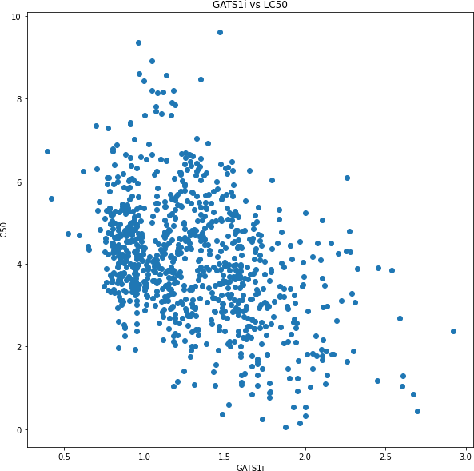

[13]:

sns.pairplot(df, hue = "NdsCH")

1. : <seaborn.axisgrid.PairGrid at 0x29efc718b50>

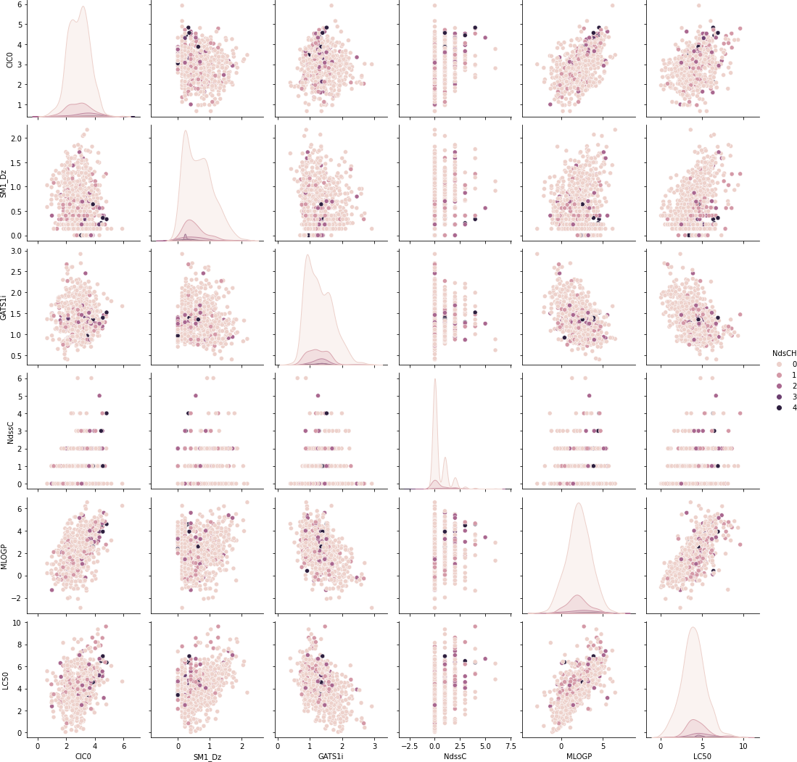

[14]:

sns.pairplot(df, hue = "NdssC")

1. : <seaborn.axisgrid.PairGrid at 0x29efcaa7400>

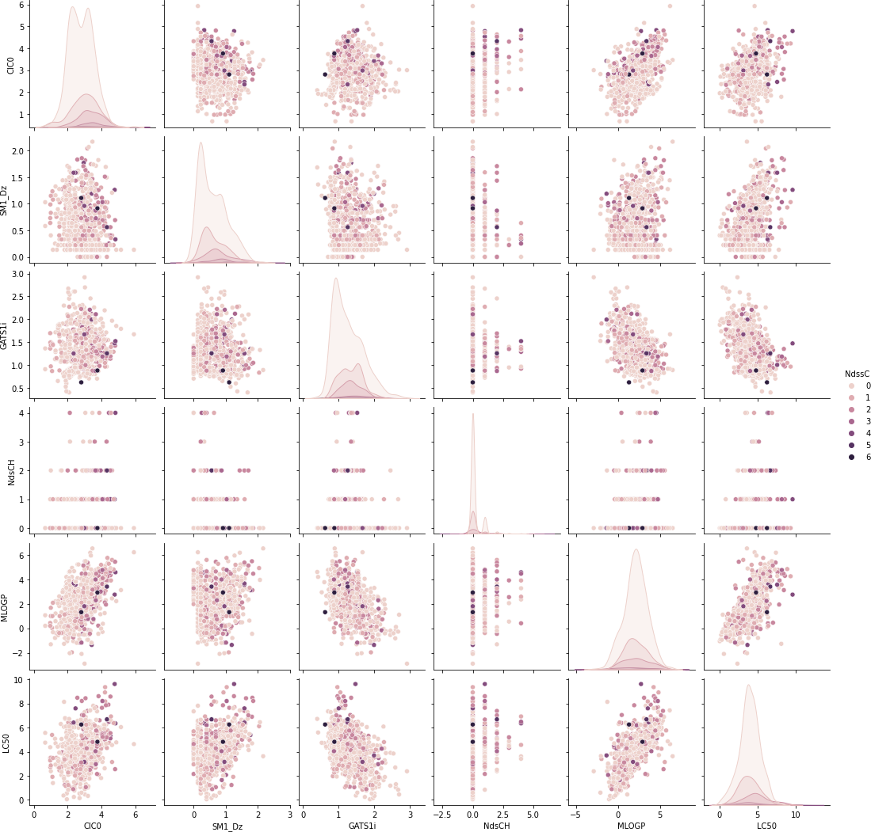

[15]:

sns.pairplot(df, hue = "LC50")

1. : <seaborn.axisgrid.PairGrid at 0x29efeb51280>

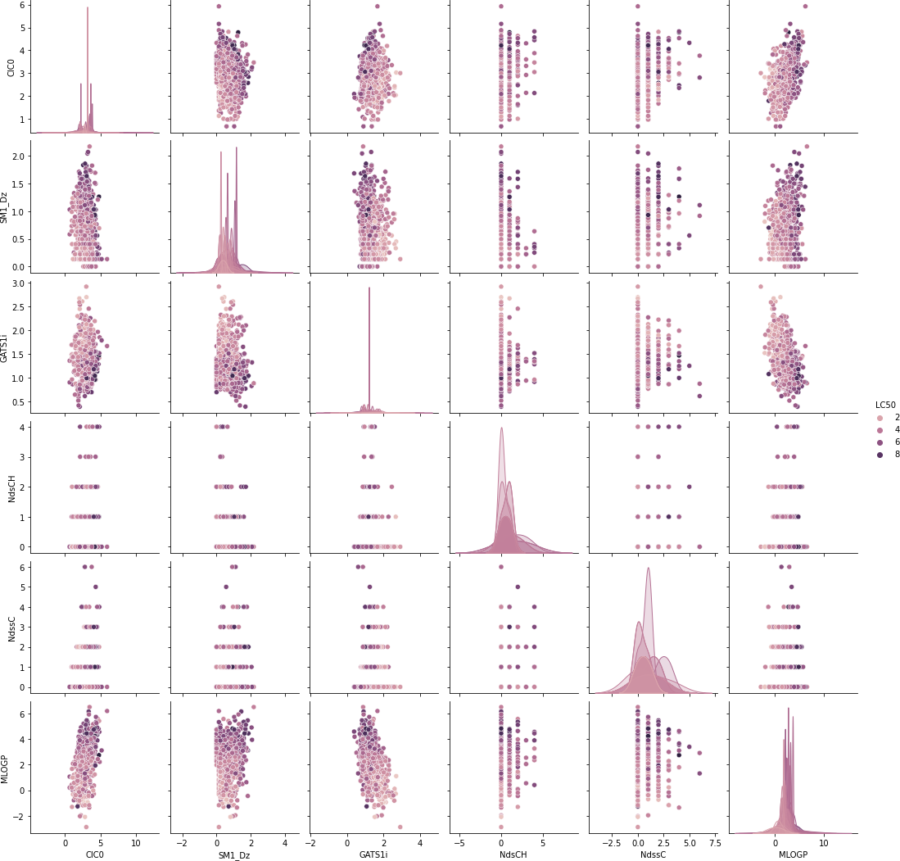

[16]:

corr = df.corr() plt.figure(figsize = (10,10))

sns.heatmap(corr, annot = **True**).set(title = "Correlation Matrix")

1. : [Text(0.5, 1.0, 'Correlation Matrix')]

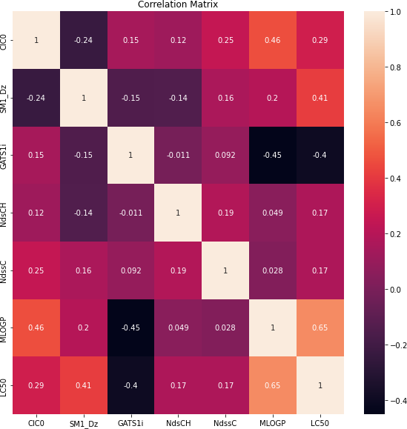

[17]:

X = df.iloc[:, 0:6] scaler = StandardScaler()

X_scaled = scaler.fit_transform(X) df_scaled = df

df_scaled.iloc[:, 0:6] = X_scaled

Train, Test = train_test_split(df_scaled, test_size=0.2, random_state=101) X_test = Test.iloc[:, 0:6]

# Normalize, Split the Data, and Perform Dimensionality Reduc- tion

y_test = Test.iloc[:, 6:] X_train = Train.iloc[:, 0:6] y_train = Train.iloc[:, 6:]

[81]:

plt.figure(figsize = (15,10)) pca = PCA(n_components=2)

pc = pca.fit_transform(X_scaled)

plot = plt.scatter(pc[:,0], pc[:,1], c=df.iloc[:, 6:].values) plt.xlabel("PC1")

plt.ylabel("PC2") plt.title("PCA")

plt.colorbar(plot, label = "LC50") plt.show()

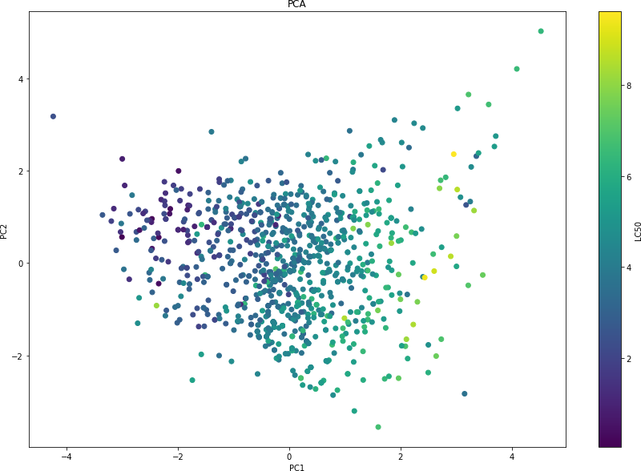

[74]:

reducer = umap.UMAP(target_metric='l1', random_state=101)

embedding = reducer.fit_transform(X_scaled, y = df.iloc[:, 6:].values)

[75]:

plt.figure(figsize = (15,10))

plot = plt.scatter(embedding[:,0], embedding[:,1], c=df.iloc[:, 6:].values) plt.title("UMAP")

plt.xlabel("UMAP 1")

plt.ylabel("UMAP 2") plt.colorbar(plot, label = "LC50") plt.show()

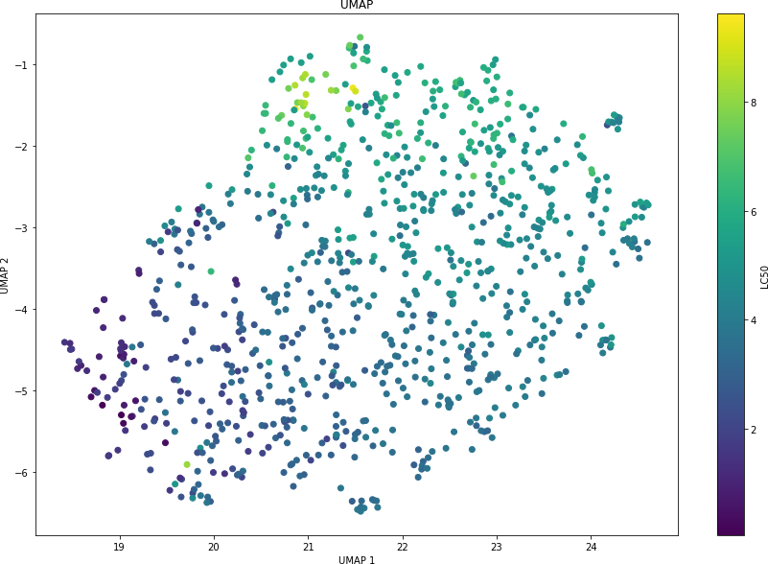

[15]:

# Univariate Model Exploration

## CIC0 vs LC50

mod = smf.ols(formula = "LC50~CIC0", data = Train).fit() print(mod.summary())

table = sm.stats.anova_lm(mod, typ=1) print(table)

y_pred = mod.predict(X_test)

mae = mean_absolute_error(y_test, y_pred) mse = mean_squared_error(y_test, y_pred)

rmse = mean_squared_error(y_test, y_pred, squared = **False**) r2 = r2_score(y_test, y_pred)

print("MAE: **{}\n**MSE: **{}\n**RMSE: **{}\n**R_squared: **{}**".format(mae, mse, rmse, r2))

OLS Regression Results

==============================================================================

|  |  |  |  |  |  |  |
| --- | --- | --- | --- | --- | --- | --- |
| Dep. Variable: | | LC50 | R-squared: | | 0.099 | |
| Model: | | OLS | Adj. R-squared: | | 0.098 | |
| Method: | | Least Squares | F-statistic: | | 79.97 | |
| Date: | | Wed, 27 Jul 2022 | Prob (F-statistic): | | 3.14e-18 | |
| Time: | | 13:00:21 | Log-Likelihood: | | -1257.0 | |
| No. Observations: | | 726 | AIC: | | 2518. | |
| Df Residuals: | | 724 | BIC: | | 2527. | |
| Df Model: | | 1 |  | |  | |
| Covariance Type: | | nonrobust |  | |  | |
| ============================================================================== | | | | | | |
| coef std err | | | t | P>|t| | [0.025 | 0.975] |
| Intercept | 4.0056 | 0.051 | 78.850 | 0.000 | 3.906 | 4.105 |
| CIC0 | 0.4496 | 0.050 | 8.943 | 0.000 | 0.351 | 0.548 |
| ==============================================================================  Omnibus: 16.273 Durbin-Watson: 1.946 | | | | | | |
| Prob(Omnibus): | 0.000 | | Jarque-Bera (JB): | | 19.812 | |
| Skew: | 0.269 | | Prob(JB): | | 4.99e-05 | |
| Kurtosis: | 3.605 | | Cond. No. | | 1.01 | |
| ============================================================================== | | | | | | |

Notes:

[1] Standard Errors assume that the covariance matrix of the errors is correctly specified.

[16]:

df sum_sq mean_sq F PR(>F) CIC0 1.0 149.824163 149.824163 79.968749 3.137657e-18

Residual 724.0 1356.438551 1.873534 NaN NaN

MAE: 1.1518681199451974

MSE: 2.228243869070734

RMSE: 1.4927303403732148

R_squared: -0.0032098309987493856

## SM1_Dz vs LC50

mod = smf.ols(formula = "LC50~SM1_Dz", data = Train).fit() print(mod.summary())

table = sm.stats.anova_lm(mod, typ=1) print(table)

y_pred = mod.predict(X_test)

mae = mean_absolute_error(y_test, y_pred) mse = mean_squared_error(y_test, y_pred)

rmse = mean_squared_error(y_test, y_pred, squared = **False**) r2 = r2_score(y_test, y_pred)

print("MAE: **{}\n**MSE: **{}\n**RMSE: **{}\n**R_squared: **{}**".format(mae, mse, rmse, r2))

OLS Regression Results

==============================================================================

Dep. Variable: LC50 R-squared: 0.151

|  |  |  |  |  |  |  |
| --- | --- | --- | --- | --- | --- | --- |
| Model: | | OLS | Adj. R-squared: | | 0.150 | |
| Method: | | Least Squares | F-statistic: | | 129.0 | |
| Date: | | Wed, 27 Jul 2022 | Prob (F-statistic): | | 1.25e-27 | |
| Time: | | 13:00:21 | Log-Likelihood: | | -1235.6 | |
| No. Observations: | | 726 | AIC: | | 2475. | |
| Df Residuals: | | 724 | BIC: | | 2484. | |
| Df Model: | | 1 |  | |  | |
| Covariance Type: | | nonrobust |  | |  | |
| ============================================================================== | | | | | | |
| coef std err | | | t | P>|t| | [0.025 | 0.975] |
| Intercept | 4.0165 | 0.049 | 81.432 | 0.000 | 3.920 | 4.113 |
| SM1_Dz | 0.5762 | 0.051 | 11.359 | 0.000 | 0.477 | 0.676 |
| ==============================================================================  Omnibus: 12.737 Durbin-Watson: 1.987 | | | | | | |
| Prob(Omnibus): | 0.002 | | Jarque-Bera (JB): | | 17.750 | |
| Skew: | 0.169 | | Prob(JB): | | 0.000140 | |
| Kurtosis: | 3.687 | | Cond. No. | | 1.03 | |

==============================================================================

Notes:

[1] Standard Errors assume that the covariance matrix of the errors is correctly specified.

[17]:

df sum_sq mean_sq F PR(>F) SM1_Dz 1.0 227.822418 227.822418 129.019268 1.250371e-27

Residual 724.0 1278.440295 1.765802 NaN NaN

MAE: 0.9679574343670176

MSE: 1.7668341949514315

RMSE: 1.3292231546852589

R_squared: 0.2045280775935706

## GATS1i vs LC50

mod = smf.ols(formula = "LC50~GATS1i", data = Train).fit() print(mod.summary())

table = sm.stats.anova_lm(mod, typ=1) print(table)

y_pred = mod.predict(X_test)

mae = mean_absolute_error(y_test, y_pred) mse = mean_squared_error(y_test, y_pred)

rmse = mean_squared_error(y_test, y_pred, squared = **False**) r2 = r2_score(y_test, y_pred)

print("MAE: **{}\n**MSE: **{}\n**RMSE: **{}\n**R_squared: **{}**".format(mae, mse, rmse, r2))

OLS Regression Results

==============================================================================

Dep. Variable: LC50 R-squared: 0.141

Model: OLS Adj. R-squared: 0.140

|  |  |  |  |  |  |  |  |
| --- | --- | --- | --- | --- | --- | --- | --- |
| Method: | | Least Squares | | F-statistic: | | 118.7 | |
| Date: | | Wed, 27 Jul 2022 | | Prob (F-statistic): | | 1.07e-25 | |
| Time: | | 13:00:21 | | Log-Likelihood: | | -1240.0 | |
| No. Observations: | | 726 | | AIC: | | 2484. | |
| Df Residuals: | | 724 | | BIC: | | 2493. | |
| Df Model: | | 1 | |  | |  | |
| Covariance Type: | | nonrobust | |  | |  | |
| ============================================================================== | | | | | | | |
| coef std err | | | | t | P>|t| | [0.025 | 0.975] |
| Intercept | 4.0170 | 0.050 | 80.946 | | 0.000 | 3.920 | 4.114 |
| GATS1i | -0.5417 | 0.050 | -10.894 | | 0.000 | -0.639 | -0.444 |
| ==============================================================================  Omnibus: 38.807 Durbin-Watson: 1.998 | | | | | | | |
| Prob(Omnibus): | 0.000 | | | Jarque-Bera (JB): | | 47.144 | |
| Skew: | 0.514 | | | Prob(JB): | | 5.79e-11 | |
| Kurtosis: | 3.708 | | | Cond. No. | | 1.02 | |

==============================================================================

Notes:

[1] Standard Errors assume that the covariance matrix of the errors is correctly specified.

[18]:

df sum_sq mean_sq F PR(>F) GATS1i 1.0 212.150803 212.150803 118.689257 1.065895e-25

Residual 724.0 1294.111910 1.787447 NaN NaN

MAE: 1.0042377587990872

MSE: 1.7954857477079382

RMSE: 1.339957367869567

R_squared: 0.1916284485189962

## NdsCH vs LC50

mod = smf.ols(formula = "LC50~NdsCH", data = Train).fit() print(mod.summary())

table = sm.stats.anova_lm(mod, typ=1) print(table)

y_pred = mod.predict(X_test)

mae = mean_absolute_error(y_test, y_pred) mse = mean_squared_error(y_test, y_pred)

rmse = mean_squared_error(y_test, y_pred, squared = **False**) r2 = r2_score(y_test, y_pred)

print("MAE: **{}\n**MSE: **{}\n**RMSE: **{}\n**R_squared: **{}**".format(mae, mse, rmse, r2))

OLS Regression Results

==============================================================================

|  |  |  |  |
| --- | --- | --- | --- |
| Dep. Variable: | LC50 | R-squared: | 0.035 |
| Model: | OLS | Adj. R-squared: | 0.034 |
| Method: | Least Squares | F-statistic: | 26.32 |

|  |  |  |  |  |  |  |
| --- | --- | --- | --- | --- | --- | --- |
| Date: | | Wed, 27 Jul 2022 | Prob (F-statistic): | | 3.73e-07 | |
| Time: | | 13:00:21 | Log-Likelihood: | | -1282.1 | |
| No. Observations: | | 726 | AIC: | | 2568. | |
| Df Residuals: | | 724 | BIC: | | 2577. | |
| Df Model: | | 1 |  | |  | |
| Covariance Type: | | nonrobust |  | |  | |
| ============================================================================== | | | | | | |
| coef std err | | | t | P>|t| | [0.025 | 0.975] |
| Intercept | 4.0059 | 0.053 | 76.178 | 0.000 | 3.903 | 4.109 |
| NdsCH | 0.2618 | 0.051 | 5.130 | 0.000 | 0.162 | 0.362 |
| ==============================================================================  Omnibus: 20.415 Durbin-Watson: 1.960 | | | | | | |
| Prob(Omnibus): | 0.000 | | Jarque-Bera (JB): | | 26.860 | |
| Skew: | 0.292 | | Prob(JB): | | 1.47e-06 | |
| Kurtosis: | 3.739 | | Cond. No. | | 1.03 | |

==============================================================================

Notes:

[1] Standard Errors assume that the covariance matrix of the errors is correctly specified.

[19]:

df sum_sq mean_sq F PR(>F) NdsCH 1.0 52.829295 52.829295 26.315901 3.726305e-07

Residual 724.0 1453.433418 2.007505 NaN NaN

MAE: 1.1750910409244002

MSE: 2.2797661983049387

RMSE: 1.5098894655917494

R_squared: -0.026406442429465216

## NdssC vs LC50

mod = smf.ols(formula = "LC50~NdssC", data = Train).fit() print(mod.summary())

table = sm.stats.anova_lm(mod, typ=1) print(table)

y_pred = mod.predict(X_test)

mae = mean_absolute_error(y_test, y_pred) mse = mean_squared_error(y_test, y_pred)

rmse = mean_squared_error(y_test, y_pred, squared = **False**) r2 = r2_score(y_test, y_pred)

print("MAE: **{}\n**MSE: **{}\n**RMSE: **{}\n**R_squared: **{}**".format(mae, mse, rmse, r2))

OLS Regression Results

==============================================================================

|  |  |  |  |
| --- | --- | --- | --- |
| Dep. Variable: | LC50 | R-squared: | 0.023 |
| Model: | OLS | Adj. R-squared: | 0.022 |
| Method: | Least Squares | F-statistic: | 17.03 |
| Date: | Wed, 27 Jul 2022 | Prob (F-statistic): | 4.10e-05 |

|  |  |  |  |  |  |  |
| --- | --- | --- | --- | --- | --- | --- |
| Time: | | 13:00:21 | Log-Likelihood: | | -1286.6 | |
| No. Observations: | | 726 | AIC: | | 2577. | |
| Df Residuals: | | 724 | BIC: | | 2586. | |
| Df Model: | | 1 |  | |  | |
| Covariance Type: | | nonrobust |  | |  | |
| ============================================================================== | | | | | | |
| coef std err | | | t | P>|t| | [0.025 | 0.975] |
| Intercept | 4.0051 | 0.053 | 75.686 | 0.000 | 3.901 | 4.109 |
| NdssC | 0.2227 | 0.054 | 4.127 | 0.000 | 0.117 | 0.329 |
| ==============================================================================  Omnibus: 8.540 Durbin-Watson: 1.973 | | | | | | |
| Prob(Omnibus): | 0.014 | | Jarque-Bera (JB): | | 9.901 | |
| Skew: | 0.169 | | Prob(JB): | | 0.00708 | |
| Kurtosis: | 3.461 | | Cond. No. | | 1.02 | |

==============================================================================

Notes:

[1] Standard Errors assume that the covariance matrix of the errors is correctly specified.

[20]:

df sum_sq mean_sq F PR(>F) NdssC 1.0 34.623039 34.623039 17.033436 0.000041

Residual 724.0 1471.639674 2.032651 NaN NaN

MAE: 1.149265041501467

MSE: 2.18208473043618

RMSE: 1.477188116130163

R_squared: 0.01757214098887272

## MLOGP vs LC50

mod = smf.ols(formula = "LC50~MLOGP", data = Train).fit() print(mod.summary())

table = sm.stats.anova_lm(mod, typ=1) print(table)

y_pred = mod.predict(X_test)

mae = mean_absolute_error(y_test, y_pred) mse = mean_squared_error(y_test, y_pred)

rmse = mean_squared_error(y_test, y_pred, squared = **False**) r2 = r2_score(y_test, y_pred)

print("MAE: **{}\n**MSE: **{}\n**RMSE: **{}\n**R_squared: **{}**".format(mae, mse, rmse, r2))

OLS Regression Results

==============================================================================

|  |  |  |  |
| --- | --- | --- | --- |
| Dep. Variable: | LC50 | R-squared: | 0.423 |
| Model: | OLS | Adj. R-squared: | 0.422 |
| Method: | Least Squares | F-statistic: | 531.3 |
| Date: | Wed, 27 Jul 2022 | Prob (F-statistic): | 1.38e-88 |
| Time: | 13:00:21 | Log-Likelihood: | -1095.3 |

|  |  |  |  |  |  |  |
| --- | --- | --- | --- | --- | --- | --- |
| No. Observations: | | 726 | AIC: | 2195. | | |
| Df Residuals: | | 724 | BIC: | 2204. | | |
| Df Model: | | 1 |  |  | | |
| Covariance Type: | | nonrobust |  |  | | |
| ============================================================================== | | | | | | |
| coef std err | | | t | P>|t| | [0.025 | 0.975] |
| Intercept | 4.0443 | 0.041 | 99.405 | 0.000 | 3.964 | 4.124 |
| MLOGP | 0.9410 | 0.041 | 23.050 | 0.000 | 0.861 | 1.021 |
| ==============================================================================  Omnibus: 123.874 Durbin-Watson: 2.037 | | | | | | |
| Prob(Omnibus): | 0.000 | | Jarque-Bera (JB): | | 322.369 | |
| Skew: | 0.877 | | Prob(JB): | | 9.97e-71 | |
| Kurtosis: | 5.753 | | Cond. No. | | 1.04 | |
| ============================================================================== | | | | | | |

Notes:

[1] Standard Errors assume that the covariance matrix of the errors is correctly specified.

[26]:

df sum_sq mean_sq F PR(>F) MLOGP 1.0 637.505102 637.505102 531.280172 1.377389e-88

Residual 724.0 868.757612 1.199941 NaN NaN

MAE: 0.8431096632604543

MSE: 1.3046098164437467

RMSE: 1.1421951744092367

R_squared: 0.41263278600664965

# Model Exploration

## Multivariate Model with Every Factor

mod_1 = smf.ols(formula = "LC50~(CIC0+SM1_Dz+GATS1i+NdsCH+NdssC+MLOGP)", data =␣

*'→*Train).fit()

print(mod_1.summary())

table = sm.stats.anova_lm(mod_1, typ=1) print(table)

variables = mod_1.model.exog y_pred = mod_1.predict(X_test)

mae = mean_absolute_error(y_test, y_pred) mse = mean_squared_error(y_test, y_pred)

rmse = mean_squared_error(y_test, y_pred, squared = **False**) r2 = r2_score(y_test, y_pred)

cls = Linear_Reg_Diagnostic(mod_1)

print("MAE: **{}\n**MSE: **{}\n**RMSE: **{}\n**R_squared: **{}**".format(mae, mse, rmse, r2))

OLS Regression Results

==============================================================================

Dep. Variable: LC50 R-squared: 0.564

|  |  |  |  |
| --- | --- | --- | --- |
| Model: | OLS | Adj. R-squared: | 0.561 |
| Method: | Least Squares | F-statistic: | 155.2 |
| Date: | Wed, 03 Aug 2022 | Prob (F-statistic): | 4.06e-126 |
| Time: | 17:41:47 | Log-Likelihood: | -993.50 |
| No. Observations: | 726 | AIC: | 2001. |
| Df Residuals: | 719 | BIC: | 2033. |
| Df Model: | 6 |  |  |
| Covariance Type: | nonrobust |  |  |

==============================================================================

coef std err t P>|t| [0.025 0.975]

|  |  |  |  |  |  |  |  |
| --- | --- | --- | --- | --- | --- | --- | --- |
| Intercept | 4.0379 | 0.036 | 113.732 | | 0.000 | 3.968 | 4.108 |
| CIC0 | 0.2863 | 0.052 | 5.476 | | 0.000 | 0.184 | 0.389 |
| SM1_Dz | 0.5260 | 0.042 | 12.484 | | 0.000 | 0.443 | 0.609 |
| GATS1i | -0.2717 | 0.045 | -5.971 | | 0.000 | -0.361 | -0.182 |
| NdsCH | 0.2326 | 0.036 | 6.405 | | 0.000 | 0.161 | 0.304 |
| NdssC | 0.0476 | 0.041 | 1.174 | | 0.241 | -0.032 | 0.127 |
| MLOGP | 0.5696 | 0.055 | 10.325 | | 0.000 | 0.461 | 0.678 |
| ============================================================================== | | | | | | | |
| Omnibus: | 91.056 | | | Durbin-Watson: | | 1.968 | |
| Prob(Omnibus): | 0.000 | | | Jarque-Bera (JB): | | 357.171 | |
| Skew: | 0.522 | | | Prob(JB): | | 2.76e-78 | |
| Kurtosis: | 6.274 | | | Cond. No. | | 2.91 | |

==============================================================================

Notes:

[1] Standard Errors assume that the covariance matrix of the errors is correctly specified.

|  |  |  |  |  |  |
| --- | --- | --- | --- | --- | --- |
|  | df | sum_sq | mean_sq | F | PR(>F) |
| CIC0 | 1.0 | 149.824163 | 149.824163 | 164.140644 | 5.401678e-34 |
| SM1_Dz | 1.0 | 332.561060 | 332.561060 | 364.339007 | 5.071243e-66 |
| GATS1i | 1.0 | 222.531248 | 222.531248 | 243.795272 | 1.525815e-47 |
| NdsCH | 1.0 | 46.872834 | 46.872834 | 51.351778 | 1.917520e-12 |
| NdssC | 1.0 | 0.874501 | 0.874501 | 0.958064 | 3.280044e-01 |
| MLOGP | 1.0 | 97.310678 | 97.310678 | 106.609222 | 2.125854e-23 |
| Residual | 719.0 | 656.288230 | 0.912779 | NaN | NaN |

[23]:

MAE: 0.6646693501498407

MSE: 0.8671610192409167

RMSE: 0.9312148083234698

R_squared: 0.609582922391621

fig, ax = cls()

C:\Users\matth\anaconda3\lib\site-packages\statsmodels\graphics\gofplots.py:993: UserWarning: marker is redundantly defined by the 'marker' keyword argument and the fmt string "bo" (-> marker='o'). The keyword argument will take precedence.

ax.plot(x, y, fmt, **plot_style)

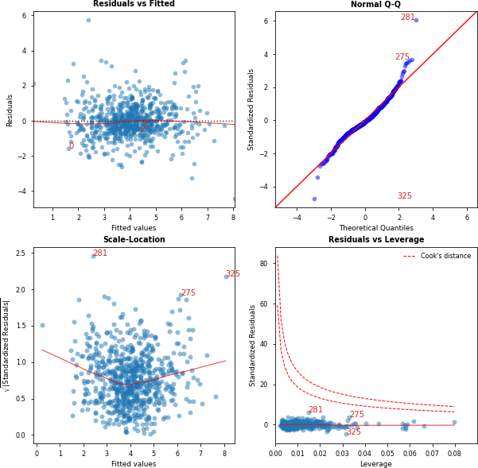

Features VIF Factor

|  |  |  |
| --- | --- | --- |
| 0 | Intercept | 1.00 |
| 4 | NdsCH | 1.11 |
| 5 | NdssC | 1.26 |
| 2 | SM1_Dz | 1.33 |
| 3 | GATS1i | 1.64 |
| 1 | CIC0 | 2.22 |
| 6 | MLOGP | 2.40 |

[27]:

## Reduced Model

OLS Regression Results

mod_2 = smf.ols(formula = "LC50~CIC0+SM1_Dz+GATS1i+NdsCH+MLOGP", data = Train).

*'→*fit()

print(mod_2.summary())

table = sm.stats.anova_lm(mod_2, typ=1) print(table)

table = sm.stats.anova_lm(mod_2,mod_1, typ=1) print(table)

variables = mod_2.model.exog

y_pred = mod_2.predict(X_test)

mae = mean_absolute_error(y_test, y_pred) mse = mean_squared_error(y_test, y_pred)

rmse = mean_squared_error(y_test, y_pred, squared = **False**) r2 = r2_score(y_test, y_pred)

cls = Linear_Reg_Diagnostic(mod_2)

print("MAE: **{}\n**MSE: **{}\n**RMSE: **{}\n**R_squared: **{}**".format(mae, mse, rmse, r2))

|  |  |  |  |  |  |  |  |
| --- | --- | --- | --- | --- | --- | --- | --- |
| ============================================================================== | | | | | | | |
| Dep. Variable: | | LC50 | | R-squared: | | 0.563 | |
| Model: | | OLS | | Adj. R-squared: | | 0.560 | |
| Method: | | Least Squares | | F-statistic: | | 185.9 | |
| Date: | | Wed, 03 Aug 2022 | | Prob (F-statistic): | | 5.62e-127 | |
| Time: | | 17:41:50 | | Log-Likelihood: | | -994.20 | |
| No. Observations: | | 726 | | AIC: | | 2000. | |
| Df Residuals: | | 720 | | BIC: | | 2028. | |
| Df Model: | | 5 | |  | |  | |
| Covariance Type: | | nonrobust | |  | |  | |
| ============================================================================== | | | | | | | |
| coef std err | | | | t | P>|t| | [0.025 | 0.975] |
| Intercept | 4.0381 | 0.036 | 113.707 | | 0.000 | 3.968 | 4.108 |
| CIC0 | 0.3066 | 0.049 | 6.215 | | 0.000 | 0.210 | 0.403 |
| SM1_Dz | 0.5407 | 0.040 | 13.437 | | 0.000 | 0.462 | 0.620 |
| GATS1i | -0.2729 | 0.045 | -5.997 | | 0.000 | -0.362 | -0.184 |
| NdsCH | 0.2432 | 0.035 | 6.915 | | 0.000 | 0.174 | 0.312 |
| MLOGP | 0.5562 | 0.054 | 10.302 | | 0.000 | 0.450 | 0.662 |
| ==============================================================================  Omnibus: 92.661 Durbin-Watson: 1.975 | | | | | | | |
| Prob(Omnibus): | 0.000 | | | Jarque-Bera (JB): | | 364.204 | |
| Skew: | 0.533 | | | Prob(JB): | | 8.20e-80 | |
| Kurtosis: | 6.302 | | | Cond. No. | | 2.71 | |
| ============================================================================== | | | | | | | |

Notes:

[1] Standard Errors assume that the covariance matrix of the errors is correctly

|  |  |  |  |  |  |  |  |  |
| --- | --- | --- | --- | --- | --- | --- | --- | --- |
| specified. | df | sum_sq | mean_sq | F | | PR(>F) | | |
| CIC0 | 1.0 | 149.824163 | 149.824163 | 164.054642 | | 5.539706e-34 | | |
| SM1_Dz | 1.0 | 332.561060 | 332.561060 | 364.148110 | | 5.207671e-66 | | |
| GATS1i | 1.0 | 222.531248 | 222.531248 | 243.667534 | | 1.569730e-47 | | |
| NdsCH | 1.0 | 46.872834 | 46.872834 | 51.324872 | | 1.939865e-12 | | |
| MLOGP | 1.0 | 96.927875 | 96.927875 | 106.134201 | | 2.607435e-23 | | |
| Residual 720.0 df_resid | | 657.545534 0.913258  ssr df_diff ss_diff | | | NaN | F | Pr(>F) | NaN |

[28]:

0 720.0 657.545534 0.0 NaN NaN NaN

1 719.0 656.288230 1.0 1.257304 1.377446 0.240925

MAE: 0.6648025405914847

MSE: 0.8725132414740466

RMSE: 0.9340841725851299

R_squared: 0.6071732211751176

fig, ax = cls()

C:\Users\matth\anaconda3\lib\site-packages\statsmodels\graphics\gofplots.py:993: UserWarning: marker is redundantly defined by the 'marker' keyword argument and the fmt string "bo" (-> marker='o'). The keyword argument will take precedence.

ax.plot(x, y, fmt, **plot_style)

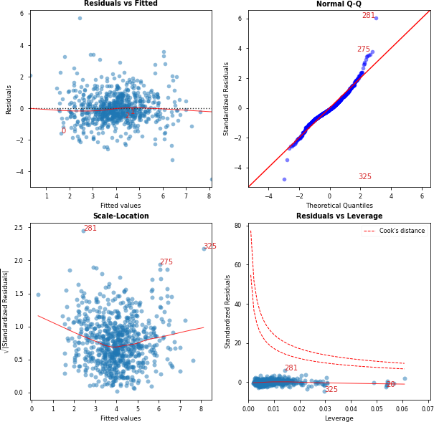

Features VIF Factor

|  |  |  |
| --- | --- | --- |
| 0 | Intercept | 1.00 |
| 4 | NdsCH | 1.04 |
| 2 | SM1_Dz | 1.22 |
| 3 | GATS1i | 1.64 |
| 1 | CIC0 | 1.98 |
| 5 | MLOGP | 2.30 |

# Interaction Testing

## All First Order Interaction Terms

[29]: mod_3 = smf.ols(formula =␣

*'→*"LC50~(CIC0+SM1_Dz+GATS1i+NdsCH+NdssC+MLOGP)*(CIC0+SM1_Dz+GATS1i+NdsCH+NdssC+MLOGP)",␣

*'→*data = Train).fit() print(mod_3.summary())

table = sm.stats.anova_lm(mod_3, typ=1) print(table)

variables = mod_3.model.exog y_pred = mod_3.predict(X_test)

mae = mean_absolute_error(y_test, y_pred) mse = mean_squared_error(y_test, y_pred)

rmse = mean_squared_error(y_test, y_pred, squared = **False**) r2 = r2_score(y_test, y_pred)

cls = Linear_Reg_Diagnostic(mod_3)

print("MAE: **{}\n**MSE: **{}\n**RMSE: **{}\n**R_squared: **{}**".format(mae, mse, rmse, r2))

|  |  |  |  |  |  |
| --- | --- | --- | --- | --- | --- |
| OLS Regression Results  ============================================================================== | | | | | |
| Dep. Variable: | LC50 | | R-squared: | | 0.614 |
| Model: | OLS | | Adj. R-squared: | | 0.603 |
| Method: | Least Squares | | F-statistic: | | 53.42 |
| Date: | Wed, 03 Aug 2022 | | Prob (F-statistic): | | 3.18e-130 |
| Time: | 17:42:28 | | Log-Likelihood: | | -949.12 |
| No. Observations: | 726 | | AIC: | | 1942. |
| Df Residuals: | 704 | | BIC: | | 2043. |
| Df Model: | 21 | |  | |  |
| Covariance Type: | nonrobust | |  | |  |
| ================================================================================  = | | | | | |
|  | coef | std err | t | P>|t| | [0.025 |
| 0.975] |  |  |  |  |  |
| - |  |  |  |  |  |
| Intercept | 3.8885 | 0.049 | 79.473 | 0.000 | 3.792 |
| 3.985 |  |  |  |  |  |
| CIC0 | 0.3172 | 0.060 | 5.250 | 0.000 | 0.199 |
| 0.436 |  |  |  |  |  |
| SM1_Dz | 0.6134 | 0.044 | 13.825 | 0.000 | 0.526 |
| 0.700 |  |  |  |  |  |
| GATS1i | -0.2828 | 0.050 | -5.631 | 0.000 | -0.381 |
| -0.184 |  |  |  |  |  |
| NdsCH | 0.2652 | 0.048 | 5.522 | 0.000 | 0.171 |
| 0.360 |  |  |  |  |  |
| NdssC | -0.0940 | 0.051 | -1.836 | 0.067 | -0.194 |
| 0.007 |  |  |  |  |  |

|  |  |  |  |  |  |
| --- | --- | --- | --- | --- | --- |
| MLOGP | 0.5200 | 0.067 | 7.713 | 0.000 | 0.388 |
| 0.652 |  |  |  |  |  |
| CIC0:SM1_Dz | -0.0868 | 0.053 | -1.647 | 0.100 | -0.190 |
| 0.017 |  |  |  |  |  |
| CIC0:GATS1i | 0.0519 | 0.048 | 1.077 | 0.282 | -0.043 |
| 0.146 |  |  |  |  |  |
| CIC0:NdsCH | -0.0567 | 0.066 | -0.863 | 0.388 | -0.186 |
| 0.072 |  |  |  |  |  |
| CIC0:NdssC | 0.1522 | 0.052 | 2.953 | 0.003 | 0.051 |
| 0.253 |  |  |  |  |  |
| CIC0:MLOGP | 0.1543 | 0.034 | 4.529 | 0.000 | 0.087 |
| 0.221 |  |  |  |  |  |
| SM1_Dz:GATS1i | 0.0179 | 0.050 | 0.357 | 0.721 | -0.081 |
| 0.116 |  |  |  |  |  |
| SM1_Dz:NdsCH | 0.0152 | 0.048 | 0.318 | 0.751 | -0.079 |
| 0.109 |  |  |  |  |  |
| SM1_Dz:NdssC | 0.2140 | 0.044 | 4.834 | 0.000 | 0.127 |
| 0.301 |  |  |  |  |  |
| SM1_Dz:MLOGP | -0.0593 | 0.048 | -1.233 | 0.218 | -0.154 |
| 0.035 |  |  |  |  |  |
| GATS1i:NdsCH | 0.0352 | 0.057 | 0.618 | 0.537 | -0.077 |
| 0.147 |  |  |  |  |  |
| GATS1i:NdssC | -0.0024 | 0.044 | -0.054 | 0.957 | -0.089 |
| 0.085 |  |  |  |  |  |
| GATS1i:MLOGP | -0.0179 | 0.040 | -0.447 | 0.655 | -0.096 |
| 0.061 |  |  |  |  |  |
| NdsCH:NdssC | 0.0499 | 0.031 | 1.594 | 0.111 | -0.012 |
| 0.111 |  |  |  |  |  |
| NdsCH:MLOGP | -0.1503 | 0.070 | -2.159 | 0.031 | -0.287 |
| -0.014 |  |  |  |  |  |
| NdssC:MLOGP | -0.0313 | 0.049 | -0.637 | 0.524 | -0.128 |
| 0.065 |  |  |  |  |  |
| ============================================================================== | | | | | |
| Omnibus: | 63.570 | | Durbin-Watson: | | 1.943 |
| Prob(Omnibus): | 0.000 | | Jarque-Bera (JB): | | 249.871 |
| Skew: | 0.301 | | Prob(JB): | | 5.51e-55 |
| Kurtosis: | 5.810 | | Cond. No. | | 8.29 |

==============================================================================

Notes:

|  |  |  |
| --- | --- | --- |
| [1] Standard specified. | Errors assume that the covariance matrix of  df sum_sq mean_sq F | the errors is correctly  PR(>F) |
| CIC0 | 1.0 149.824163 149.824163 181.616861 | 5.428992e-37 |
| SM1_Dz | 1.0 332.561060 332.561060 403.130541 | 3.047164e-71 |
| GATS1i | 1.0 222.531248 222.531248 269.752395 | 1.468387e-51 |
| NdsCH | 1.0 46.872834 46.872834 56.819253 | 1.474241e-13 |
| NdssC | 1.0 0.874501 0.874501 1.060070 | 3.035529e-01 |

|  |  |  |  |  |  |
| --- | --- | --- | --- | --- | --- |
| MLOGP | 1.0 | 97.310678 | 97.310678 | 117.960011 | 1.637170e-25 |
| CIC0:SM1_Dz | 1.0 | 0.447692 | 0.447692 | 0.542692 | 4.615646e-01 |
| CIC0:GATS1i | 1.0 | 0.073509 | 0.073509 | 0.089107 | 7.654034e-01 |
| CIC0:NdsCH | 1.0 | 13.029795 | 13.029795 | 15.794718 | 7.788002e-05 |
| CIC0:NdssC | 1.0 | 9.908538 | 9.908538 | 12.011131 | 5.609252e-04 |
| CIC0:MLOGP | 1.0 | 19.988482 | 19.988482 | 24.230039 | 1.065758e-06 |
| SM1_Dz:GATS1i | 1.0 | 1.849727 | 1.849727 | 2.242240 | 1.347346e-01 |
| SM1_Dz:NdsCH | 1.0 | 1.266545 | 1.266545 | 1.535306 | 2.157308e-01 |
| SM1_Dz:NdssC | 1.0 | 16.334674 | 16.334674 | 19.800894 | 9.988010e-06 |
| SM1_Dz:MLOGP | 1.0 | 1.180579 | 1.180579 | 1.431098 | 2.319881e-01 |
| GATS1i:NdsCH | 1.0 | 4.068860 | 4.068860 | 4.932272 | 2.667712e-02 |
| GATS1i:NdssC | 1.0 | 0.008698 | 0.008698 | 0.010544 | 9.182437e-01 |
| GATS1i:MLOGP | 1.0 | 0.153957 | 0.153957 | 0.186627 | 6.658713e-01 |
| NdsCH:NdssC | 1.0 | 2.445800 | 2.445800 | 2.964799 | 8.553430e-02 |
| NdsCH:MLOGP | 1.0 | 4.433940 | 4.433940 | 5.374822 | 2.071503e-02 |
| NdssC:MLOGP | 1.0 | 0.335218 | 0.335218 | 0.406351 | 5.240346e-01 |
| Residual | 704.0 | 580.762216 | 0.824946 | NaN | NaN |

[30]:

MAE: 0.6252053863994669

MSE: 0.8722338398525055

RMSE: 0.9339346014858351

R_squared: 0.6072990146115622

fig, ax = cls()

C:\Users\matth\anaconda3\lib\site-packages\statsmodels\graphics\gofplots.py:993: UserWarning: marker is redundantly defined by the 'marker' keyword argument and the fmt string "bo" (-> marker='o'). The keyword argument will take precedence.

ax.plot(x, y, fmt, **plot_style)

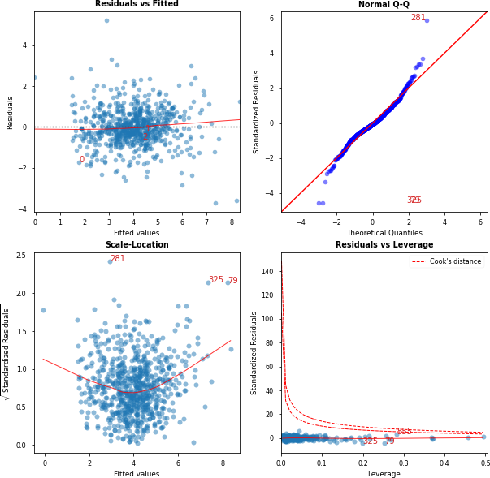

|  |  |  |
| --- | --- | --- |
|  | Features | VIF Factor |
| 11 | CIC0:MLOGP | 1.35 |
| 14 | SM1_Dz:NdssC | 1.47 |
| 16 | GATS1i:NdsCH | 1.64 |
| 2 | SM1_Dz | 1.64 |
| 17 | GATS1i:NdssC | 1.68 |
| 8 | CIC0:GATS1i | 1.72 |
| 13 | SM1_Dz:NdsCH | 1.78 |
| 18 | GATS1i:MLOGP | 1.81 |
| 12 | SM1_Dz:GATS1i | 1.93 |
| 7 | CIC0:SM1_Dz | 2.10 |
| 0 | Intercept | 2.11 |
| 4 | NdsCH | 2.16 |
| 3 | GATS1i | 2.21 |

|  |  |  |
| --- | --- | --- |
| 5 | NdssC | 2.22 |
| 19 | NdsCH:NdssC | 2.60 |
| 15 | SM1_Dz:MLOGP | 2.71 |
| 21 | NdssC:MLOGP | 2.72 |
| 10 | CIC0:NdssC | 2.99 |
| 1 | CIC0 | 3.28 |
| 6 | MLOGP | 3.97 |
| 20 | NdsCH:MLOGP | 5.49 |
| 9 | CIC0:NdsCH | 7.53 |

[24]:

## Reduced Interactions Model

OLS Regression Results

mod_4 = smf.ols(formula = "LC50~CIC0+SM1_Dz+GATS1i+NdsCH+MLOGP+CIC0:NdssC+CIC0:

*'→*MLOGP+SM1_Dz:NdssC+NdsCH:MLOGP", data = Train).fit() print(mod_4.summary())

table = sm.stats.anova_lm(mod_4, typ=1) print(table)

table = sm.stats.anova_lm(mod_4,mod_3, typ=1) print(table)

variables = mod_4.model.exog

vif = [variance_inflation_factor(variables, i) **for** i **in** range(variables.

*'→*shape[1])]

print(vif)

y_pred = mod_4.predict(X_test)

mae = mean_absolute_error(y_test, y_pred) mse = mean_squared_error(y_test, y_pred)

rmse = mean_squared_error(y_test, y_pred, squared = **False**) r2 = r2_score(y_test, y_pred)

cls = Linear_Reg_Diagnostic(mod_4)

print("MAE: **{}\n**MSE: **{}\n**RMSE: **{}\n**R_squared: **{}**".format(mae, mse, rmse, r2))

==============================================================================

|  |  |  |  |  |  |  |
| --- | --- | --- | --- | --- | --- | --- |
| Dep. Variable: | LC50 | | R-squared: | | 0.603 | |
| Model: | OLS | | Adj. R-squared: | | 0.598 | |
| Method: | Least Squares | | F-statistic: | | 121.0 | |
| Date: | Wed, 27 Jul 2022 | | Prob (F-statistic): | | 2.44e-137 | |
| Time: | 13:00:21 | | Log-Likelihood: | | -959.51 | |
| No. Observations: | 726 | | AIC: | | 1939. | |
| Df Residuals: | 716 | | BIC: | | 1985. | |
| Df Model: | 9 | |  | |  | |
| Covariance Type: | nonrobust | |  | |  | |
| ================================================================================ | | | | | | |
| coef std err | | | t | P>|t| | [0.025 | 0.975] |
| Intercept | 3.9337 | 0.038 | 103.544 | 0.000 | 3.859 | 4.008 |
| CIC0 | 0.3073 | 0.049 | 6.314 | 0.000 | 0.212 | 0.403 |
| SM1_Dz | 0.5587 | 0.040 | 14.049 | 0.000 | 0.481 | 0.637 |

|  |  |  |  |  |  |  |
| --- | --- | --- | --- | --- | --- | --- |
| GATS1i | -0.2886 | 0.044 | -6.526 | 0.000 | -0.375 | -0.202 |
| NdsCH | 0.2483 | 0.036 | 6.813 | 0.000 | 0.177 | 0.320 |
| MLOGP | 0.5476 | 0.053 | 10.290 | 0.000 | 0.443 | 0.652 |
| CIC0:NdssC | 0.1103 | 0.035 | 3.192 | 0.001 | 0.042 | 0.178 |
| CIC0:MLOGP | 0.1440 | 0.031 | 4.578 | 0.000 | 0.082 | 0.206 |
| SM1_Dz:NdssC | 0.1658 | 0.038 | 4.370 | 0.000 | 0.091 | 0.240 |
| NdsCH:MLOGP | -0.1739 | 0.034 | -5.123 | 0.000 | -0.241 | -0.107 |
| ============================================================================== | | | | | | |
| Omnibus: | 61.426 | | Durbin-Watson: | | 1.938 | |
| Prob(Omnibus): | 0.000 | | Jarque-Bera (JB): | | 266.636 | |
| Skew: | 0.229 | | Prob(JB): | | 1.26e-58 | |
| Kurtosis: | 5.933 | | Cond. No. | | 3.63 | |

==============================================================================

Notes:

[1] Standard Errors assume that the covariance matrix of the errors is correctly specified.

|  |  |  |  |  |  |
| --- | --- | --- | --- | --- | --- |
|  | df | sum_sq | mean_sq | F | PR(>F) |
| CIC0 | 1.0 | 149.824163 | 149.824163 | 179.503126 | 1.095941e-36 |
| SM1_Dz | 1.0 | 332.561060 | 332.561060 | 398.438735 | 8.115997e-71 |
| GATS1i | 1.0 | 222.531248 | 222.531248 | 266.612901 | 3.482681e-51 |
| NdsCH | 1.0 | 46.872834 | 46.872834 | 56.157966 | 1.977608e-13 |
| MLOGP | 1.0 | 96.927875 | 96.927875 | 116.128508 | 3.380675e-25 |
| CIC0:NdssC | 1.0 | 2.973956 | 2.973956 | 3.563073 | 5.948244e-02 |
| CIC0:MLOGP | 1.0 | 17.586136 | 17.586136 | 21.069809 | 5.229643e-06 |
| SM1_Dz:NdssC | 1.0 | 17.462449 | 17.462449 | 20.921620 | 5.637720e-06 |
| NdsCH:MLOGP | 1.0 | 21.906098 | 21.906098 | 26.245520 | 3.870201e-07 |
| Residual | 716.0 | 597.616893 | 0.834660 | NaN | NaN |
| df_resid |  | ssr df_diff | ss_diff | F | Pr(>F) |

[31]:

0 716.0 597.616893 0.0 NaN NaN NaN

1 704.0 580.762216 12.0 16.854678 1.702603 0.061921

[1.255416809499518, 2.1044981905482576, 1.3004538978884799, 1.6934312959727862,

1.2264784684887298, 2.443022742239267, 1.3292692131540762, 1.1348823438792845,

1.0676744718552331, 1.2905891804746232]

MAE: 0.6466933021246712

MSE: 0.9118498576541835

RMSE: 0.9549082980339962

R_squared: 0.5894629154864519

fig, ax = cls()

C:\Users\matth\anaconda3\lib\site-packages\statsmodels\graphics\gofplots.py:993: UserWarning: marker is redundantly defined by the 'marker' keyword argument and the fmt string "bo" (-> marker='o'). The keyword argument will take precedence.

ax.plot(x, y, fmt, **plot_style)



|  |  |  |
| --- | --- | --- |
|  | Features | VIF Factor |
| 11 | CIC0:MLOGP | 1.35 |
| 14 | SM1_Dz:NdssC | 1.47 |
| 16 | GATS1i:NdsCH | 1.64 |
| 2 | SM1_Dz | 1.64 |
| 17 | GATS1i:NdssC | 1.68 |
| 8 | CIC0:GATS1i | 1.72 |
| 13 | SM1_Dz:NdsCH | 1.78 |
| 18 | GATS1i:MLOGP | 1.81 |
| 12 | SM1_Dz:GATS1i | 1.93 |
| 7 | CIC0:SM1_Dz | 2.10 |
| 0 | Intercept | 2.11 |
| 4 | NdsCH | 2.16 |
| 3 | GATS1i | 2.21 |

|  |  |  |
| --- | --- | --- |
| 5 | NdssC | 2.22 |
| 19 | NdsCH:NdssC | 2.60 |
| 15 | SM1_Dz:MLOGP | 2.71 |
| 21 | NdssC:MLOGP | 2.72 |
| 10 | CIC0:NdssC | 2.99 |
| 1 | CIC0 | 3.28 |
| 6 | MLOGP | 3.97 |
| 20 | NdsCH:MLOGP | 5.49 |
| 9 | CIC0:NdsCH | 7.53 |

[32]:

# Evaluation of Linear Models

There doesn’t seem to be much good performance with Linear Models on this dataset. While the model with all first order interaction terms did perform the best, it may be due to there being more features. There was no significance between both reduced models and their respective parent model. The models with interaciton terms had less MAE, but had worse MSE, meaning errors may be bigger when interaction terms are included. *R*2 on the test data for the models without interaction was higher as well. It is unlikely that interaction is present. Assumptions for linear regression hold for each model.

# KNN Regression

## KNN Example 6 Neighbors

knn1 = KNeighborsRegressor(n_neighbors=6) knn1.fit(X_train, y_train) knn1.score(X_test, y_test)

y_pred = knn1.predict(X_test)

mae = mean_absolute_error(y_test, y_pred) mse = mean_squared_error(y_test, y_pred)

rmse = mean_squared_error(y_test, y_pred, squared = **False**) r2 = r2_score(y_test, y_pred)

print("MAE: **{}\n**MSE: **{}\n**RMSE: **{}\n**R_squared: **{}**".format(mae, mse, rmse, r2))

[33]:

MAE: 0.5972747252747254

MSE: 0.7172062567155068

RMSE: 0.8468803083762821

R_squared: 0.6770962202216795

## Grid Search Optimization for KNN

scoring = {"MSE": "neg_mean_squared_error", "R2":"r2"}

*# Setting refit='AUC', refits an estimator on the whole dataset with the # parameter setting that has the best cross-validated AUC score.*

*# That estimator is made available at ``gs.best_estimator_`` along with # parameters like ``gs.best_score_``, ``gs.best_params_`` and*

*# ``gs.best_index_``*

gs = GridSearchCV( KNeighborsRegressor(),

param_grid={"n_neighbors": range(1, 6), "weights":["uniform","distance"],␣

*'→*"p":[1,2]},

scoring=scoring, refit="MSE", return_train_score=**True**, n_jobs = -1,

cv = 100,

verbose = 3

)

gs.fit(X_train, y_train) results = gs.cv_results_

Fitting 100 folds for each of 20 candidates, totalling 2000 fits

[34]:

gs.best_params_

[34]: {'n_neighbors': 5, 'p': 1, 'weights': 'distance'}

[35]:

knn = gs.best_estimator_

[36]:

y_pred = knn.predict(X_test)

mae = mean_absolute_error(y_test, y_pred) mse = mean_squared_error(y_test, y_pred)

rmse = mean_squared_error(y_test, y_pred, squared = **False**) r2 = r2_score(y_test, y_pred)

print("MAE: **{}\n**MSE: **{}\n**RMSE: **{}\n**R_squared: **{}**".format(mae, mse, rmse, r2))

MAE: 0.549976177393366

MSE: 0.6426008012295652

RMSE: 0.8016238527074685

R_squared: 0.7106854190650043

## PCA and KNN

[28]:

**def** get_models(): models = dict()

**for** i **in** range(1,7):

steps = [('pca', PCA(n_components=i)), ('m',␣

*'→*KNeighborsRegressor(n_neighbors=5, p = 1, weights = "distance"))] models[str(i)] = Pipeline(steps=steps)

**return** models

*# evaluate a given model using cross-validation*

**def** evaluate_model(model, X, y):

cv = KFold(n_splits=5, random_state=101, shuffle = **True**)

scores = cross_val_score(model, X, y, scoring='neg_mean_squared_error',␣

*'→*cv=cv, n_jobs=-1, error_score='raise')

**return** scores

*# get the models to evaluate*

models = get_models()

*# evaluate the models and store results*

results, names = list(), list()

**for** name, model **in** models.items():

scores = evaluate_model(model, X_train, y_train) results.append(scores)

names.append(name)

print('>**%s %.3f** (**%.3f**)' % (name, mean(scores), std(scores)))

[29]:

>1 -1.738 (0.114)

>2 -1.161 (0.140)

>3 -0.950 (0.105)

>4 -0.812 (0.157)

>5 -0.866 (0.141)

>6 -0.847 (0.148)

steps = [('pca', PCA(n_components=4)), ('m', KNeighborsRegressor(n_neighbors=5,␣

*'→*p = 1, weights = "distance"))] model = Pipeline(steps=steps) model.fit(X_train, y_train) y_pred = model.predict(X_test)

mae = mean_absolute_error(y_test, y_pred) mse = mean_squared_error(y_test, y_pred)

rmse = mean_squared_error(y_test, y_pred, squared = **False**) r2 = r2_score(y_test, y_pred)

print("MAE: **{}\n**MSE: **{}\n**RMSE: **{}\n**R_squared: **{}**".format(mae, mse, rmse, r2))

MAE: 0.5937420511872225

MSE: 0.7569008399616851

RMSE: 0.8700004827364667

R_squared: 0.6592247490139198

# Evaluation of KNN

KNN improves performance on the Test dataset. It was optimized, and led to a higher *R*2 score and lower *MSE*. PCA compresses the data too much and does not allow for meaningful relationships to be seen by the model. KNN with 5 neighbors, l1 distance performs the best on the data.

[30]:

sgd_reg = SGDRegressor(max_iter=1000, tol=1e-3, penalty="l2", eta0=0.01) sgd_reg.fit(X_train, y_train.values.ravel())

sgd_reg.intercept_, sgd_reg.coef_ y_pred = sgd_reg.predict(X_test)

mae = mean_absolute_error(y_test, y_pred) mse = mean_squared_error(y_test, y_pred)

rmse = mean_squared_error(y_test, y_pred, squared = **False**) r2 = r2_score(y_test, y_pred)

print("MAE: **{}\n**MSE: **{}\n**RMSE: **{}\n**R_squared: **{}**".format(mae, mse, rmse, r2))

# Gradient Descent

[39]:

MAE: 0.6641009021334089

MSE: 0.8673091952076947

RMSE: 0.931294365497663

R_squared: 0.6095162099510966

# Evaluation of Gradient Descent

Same performance as linear model but is outperformed by KNN. Cant be optimized as well since parameters are continuous

# 11. Ridge, Lasso, and Elasticnet Regularization

## Ridge Regression

poly = PolynomialFeatures(2)

poly_X_train = poly.fit_transform(X_train) poly_X_test = poly.fit_transform(X_test) ridge_reg = Ridge(alpha=1 , solver= "auto") ridge_reg.fit(poly_X_train , y_train) y_pred= ridge_reg.predict(poly_X_test)

mae = mean_absolute_error(y_test, y_pred) mse = mean_squared_error(y_test, y_pred)

rmse = mean_squared_error(y_test, y_pred, squared = **False**) r2 = r2_score(y_test, y_pred)

print("MAE: **{}\n**MSE: **{}\n**RMSE: **{}\n**R_squared: **{}**".format(mae, mse, rmse, r2))

[62]:

MAE: 0.6192753750697797

MSE: 0.8440158736842909

RMSE: 0.9187033654473521

R_squared: 0.6200034324105659

intercept = ridge_reg.intercept_[0] print("E(y) = " + str(intercept), end =" ") i = 1

**for** coef **in** ridge_reg.coef_[0]:

print("+ " + str(coef) + "*X_"+ str(i),end =" ")

i+=1

[65]:

E(y) = 3.892252012873493 + 0.0*X_1 + 0.3009287547124961*X_2 + 0.5846542581855313*X_3 + -0.2885722891861736*X_4 + 0.33561044270534446*X_5 +

-0.04691621569339529*X_6 + 0.5147181910314026*X_7 + -0.011844581261028983*X_8 +

-0.07988945669958426*X_9 + 0.0724036613395784*X_10 + -0.027615552497574667*X_11

+ 0.17945067847378657*X_12 + 0.16240783769337988*X_13 + 0.04029647132214782*X_14

+ 0.017151044825168892*X_15 + -0.005330546352793698*X_16 + 0.23548063628815477*X_17 + -0.07834081616696212*X_18 + 0.009090663384291042*X_19

+ 0.014132939074507442*X_20 + -0.02385617257690637*X_21 +

-0.013281152434592177*X_22 + -0.02893142065627501*X_23 + 0.06865771394750197*X_24 + -0.16582416385791565*X_25 + -0.0317079979197357*X_26

+ -0.059135522124548326*X_27 + 0.0019317900535462068*X_28

## Lasso Regression

lasso_reg = Lasso(alpha = 0.05) lasso_reg.fit(poly_X_train, y_train) y_pred = lasso_reg.predict(poly_X_test) mae = mean_absolute_error(y_test, y_pred) mse = mean_squared_error(y_test, y_pred)

rmse = mean_squared_error(y_test, y_pred, squared = **False**) r2 = r2_score(y_test, y_pred)

print("MAE: **{}\n**MSE: **{}\n**RMSE: **{}\n**R_squared: **{}**".format(mae, mse, rmse, r2))

[67]:

MAE: 0.6531654769265813

MSE: 0.8695790137885683

RMSE: 0.9325122057048735

R_squared: 0.608494282169078

intercept = lasso_reg.intercept_[0] print("E(y) = " + str(intercept), end =" ") i = 1

**for** coef **in** lasso_reg.coef_:

print("+ " + str(coef) + "*X_"+ str(i),end =" ") i+=1

E(y) = 3.9173103213192504 + 0.0*X_1 + 0.19886736243419062*X_2 + 0.4559465671701525*X_3 + -0.21256611454121532*X_4 + 0.18174835873080378*X_5 +

0.0*X_6 + 0.5931181518839378*X_7 + 0.04905532044355343*X_8 + -0.0*X_9 + 0.0*X_10

+ -0.0*X_11 + 0.050231234305945914*X_12 + 0.04983652536927835*X_13 + 0.02268194583406715*X_14 + 0.0*X_15 + 0.0*X_16 + 0.09999300518796372*X_17 +

-0.03501765577178401*X_18 + -0.0*X_19 + 0.0*X_20 + 0.0*X_21 + 0.0*X_22 + 0.0*X_23 + 0.017039571692934158*X_24 + -0.10798183174529531*X_25 +

0.011519941933311422*X_26 + 0.0*X_27 + 0.0*X_28

[68]:

elastic_net = ElasticNet(alpha=0.01, l1_ratio=0.01) elastic_net.fit(poly_X_train, y_train)

y_pred = elastic_net.predict(poly_X_test) mae = mean_absolute_error(y_test, y_pred) mse = mean_squared_error(y_test, y_pred)

rmse = mean_squared_error(y_test, y_pred, squared = **False**) r2 = r2_score(y_test, y_pred)

print("MAE: **{}\n**MSE: **{}\n**RMSE: **{}\n**R_squared: **{}**".format(mae, mse, rmse, r2))

## Elasticnet

[69]:

MAE: 0.6197670116899672

MSE: 0.8445688324608495

RMSE: 0.9190042613942818

R_squared: 0.6197544768592995

intercept = elastic_net.intercept_[0] print("E(y) = " + str(intercept), end =" ") i = 1

**for** coef **in** elastic_net.coef_:

print("+ " + str(coef) + "*X_"+ str(i),end =" ") i+=1

[74]:

scoring = {"MSE": "neg_mean_squared_error", "R2":"r2"}

*# Setting refit='AUC', refits an estimator on the whole dataset with the # parameter setting that has the best cross-validated AUC score.*

*# That estimator is made available at ``gs.best_estimator_`` along with # parameters like ``gs.best_score_``, ``gs.best_params_`` and*

E(y) = 3.8846309242680777 + 0.0*X_1 + 0.2927933522346351*X_2 + 0.5701587565393743*X_3 + -0.2853155296133328*X_4 + 0.3232608010829245*X_5 +

-0.040683191849905674*X_6 + 0.5176625959975297*X_7 + -0.005686391706115492*X_8 +

-0.07347373561585265*X_9 + 0.06744551223755198*X_10 + -0.026991311089282124*X_11

+ 0.17140210905060943*X_12 + 0.1489001291691723*X_13 + 0.04387944907565253*X_14

+ 0.015432694442330381*X_15 + -0.003522939339889553*X_16 + 0.22665360496982379*X_17 + -0.07987184434323709*X_18 + 0.010778170793633652*X_19

+ 0.015419767927768628*X_20 + -0.019190216994567962*X_21 +

-0.004776018749484832*X_22 + -0.026267038845699857*X_23 + 0.06587236709111102*X_24 + -0.16512229677517617*X_25 +

-0.029005690231739913*X_26 + -0.05148489107405104*X_27 + 0.008550690699392257*X_28

# Evaluation of Regularization

Slight improvement, but not as good as KNN

# Ridge, Lasso, and Elasticnet Regularization

*# ``gs.best_index_``*

gs = GridSearchCV( RandomForestRegressor(),

param_grid={"n_estimators": [10,25,30,50,100,200], "max_depth":

*'→*[2,3,5,10,20], "min_samples_leaf":[5,10,20,50,100,200]},

scoring=scoring, refit="MSE", return_train_score=**True**, n_jobs = -1,

cv = 20,

verbose = 3

)

gs.fit(X_train, y_train.values.ravel()) results = gs.cv_results_

Fitting 20 folds for each of 180 candidates, totalling 3600 fits

[75]:

gs.best_params_

[75]: {'max_depth': 20, 'min_samples_leaf': 5, 'n_estimators': 50}

[76]:

rf = gs.best_estimator_

[77]:

y_pred = rf.predict(X_test)

mae = mean_absolute_error(y_test, y_pred) mse = mean_squared_error(y_test, y_pred)

rmse = mean_squared_error(y_test, y_pred, squared = **False**) r2 = r2_score(y_test, y_pred)

print("MAE: **{}\n**MSE: **{}\n**RMSE: **{}\n**R_squared: **{}**".format(mae, mse, rmse, r2))

[268]:

NN_model = Sequential()

NN_model.add(Dense(64, kernel_initializer='normal',input_dim = 6,␣

*'→*activation='relu'))

MAE: 0.6061146426280116

MSE: 0.7715916605381403

RMSE: 0.8784029033069849

R_squared: 0.6526105826597295

# Evaluation of Random Forest Regression

Allows for the learning of nonlinear trends, increases in performance compared to linear models and regularization techniques, indicating there is a nonlinear trend in the data.

# Neural Network Regression

NN_model.add(Dense(64, kernel_initializer='normal',activation='tanh')) NN_model.add(Dense(128, kernel_initializer='normal',activation='tanh')) NN_model.add(Dense(64, kernel_initializer='normal',activation='tanh')) NN_model.add(Dense(32, kernel_initializer='normal',activation='tanh'))

NN_model.add(Dense(1, kernel_initializer='normal',activation='linear')) NN_model.compile(loss='mean_squared_error', optimizer='rmsprop',␣

*'→*metrics=['mean_squared_error'])

NN_model.summary()

Model: "sequential_32"

Layer (type) Output Shape Param #

=================================================================

|  |  |  |  |  |
| --- | --- | --- | --- | --- |
| dense_167 | (Dense) | (None, | 64) | 448 |
| dense_168 | (Dense) | (None, | 64) | 4160 |
| dense_169 | (Dense) | (None, | 128) | 8320 |
| dense_170 | (Dense) | (None, | 64) | 8256 |
| dense_171 | (Dense) | (None, | 32) | 2080 |
| dense_172 | (Dense) | (None, | 1) | 33 |

=================================================================

Total params: 23,297

Trainable params: 23,297

Non-trainable params: 0

[269]:

checkpoint_name = 'Weights-**{epoch:03d}**--**{val_loss:.5f}**.hdf5'

checkpoint = ModelCheckpoint(checkpoint_name, monitor='val_loss', verbose = 3,␣

*'→*save_best_only = **True**, mode ='auto') callbacks_list = [checkpoint]

[270]:

**with** tf.device('/CPU:0'):

NN_model.fit(X_train, y_train, epochs=100, batch_size=1, validation_split =␣

*'→*0.2, callbacks=callbacks_list,verbose = 0)

Epoch 1: val_loss improved from inf to 0.93916, saving model to Weights-001-- 0.93916.hdf5

Epoch 2: val_loss improved from 0.93916 to 0.88233, saving model to Weights-002

--0.88233.hdf5

Epoch 3: val_loss did not improve from 0.88233

Epoch 4: val_loss improved from 0.88233 to 0.84274, saving model to Weights-004

--0.84274.hdf5

Epoch 5: val_loss did not improve from 0.84274

Epoch 6: val_loss improved from 0.84274 to 0.82479, saving model to Weights-006

--0.82479.hdf5

Epoch 7: val_loss did not improve from 0.82479 Epoch 8: val_loss did not improve from 0.82479 Epoch 9: val_loss did not improve from 0.82479

Epoch 10: val_loss improved from 0.82479 to 0.78585, saving model to Weights-010

--0.78585.hdf5

Epoch 11: val_loss improved from 0.78585 to 0.76202, saving model to Weights-011

--0.76202.hdf5

Epoch 12: val_loss did not improve from 0.76202 Epoch 13: val_loss did not improve from 0.76202

Epoch 14: val_loss improved from 0.76202 to 0.75242, saving model to Weights-014

--0.75242.hdf5

Epoch 15: val_loss did not improve from 0.75242 Epoch 16: val_loss did not improve from 0.75242 Epoch 17: val_loss did not improve from 0.75242

Epoch 18: val_loss improved from 0.75242 to 0.74493, saving model to Weights-018

--0.74493.hdf5

Epoch 19: val_loss did not improve from 0.74493 Epoch 20: val_loss did not improve from 0.74493 Epoch 21: val_loss did not improve from 0.74493

Epoch 22: val_loss improved from 0.74493 to 0.73038, saving model to Weights-022

--0.73038.hdf5

|  |  |  |  |  |  |  |  |
| --- | --- | --- | --- | --- | --- | --- | --- |
| Epoch | 23: | val_loss | did | not | improve | from | 0.73038 |
| Epoch | 24: | val_loss | did | not | improve | from | 0.73038 |
| Epoch | 25: | val_loss | did | not | improve | from | 0.73038 |
| Epoch | 26: | val_loss | did | not | improve | from | 0.73038 |
| Epoch | 27: | val_loss | did | not | improve | from | 0.73038 |
| Epoch | 28: | val_loss | did | not | improve | from | 0.73038 |
| Epoch | 29: | val_loss | did | not | improve | from | 0.73038 |
| Epoch | 30: | val_loss | did | not | improve | from | 0.73038 |
| Epoch | 31: | val_loss | did | not | improve | from | 0.73038 |
| Epoch | 32: | val_loss | did | not | improve | from | 0.73038 |
| Epoch | 33: | val_loss | did | not | improve | from | 0.73038 |
| Epoch | 34: | val_loss | did | not | improve | from | 0.73038 |
| Epoch | 35: | val_loss | did | not | improve | from | 0.73038 |
| Epoch | 36: | val_loss | did | not | improve | from | 0.73038 |
| Epoch | 37: | val_loss | did | not | improve | from | 0.73038 |
| Epoch | 38: | val_loss | did | not | improve | from | 0.73038 |
| Epoch | 39: | val_loss | did | not | improve | from | 0.73038 |

Epoch 40: val_loss improved from 0.73038 to 0.71186, saving model to Weights-040

--0.71186.hdf5

Epoch 41: val_loss did not improve from 0.71186 Epoch 42: val_loss did not improve from 0.71186 Epoch 43: val_loss did not improve from 0.71186 Epoch 44: val_loss did not improve from 0.71186 Epoch 45: val_loss did not improve from 0.71186 Epoch 46: val_loss did not improve from 0.71186

|  |  |  |  |  |  |  |  |
| --- | --- | --- | --- | --- | --- | --- | --- |
| Epoch | 47: | val_loss | did | not | improve | from | 0.71186 |
| Epoch | 48: | val_loss | did | not | improve | from | 0.71186 |
| Epoch | 49: | val_loss | did | not | improve | from | 0.71186 |
| Epoch | 50: | val_loss | did | not | improve | from | 0.71186 |
| Epoch | 51: | val_loss | did | not | improve | from | 0.71186 |
| Epoch | 52: | val_loss | did | not | improve | from | 0.71186 |
| Epoch | 53: | val_loss | did | not | improve | from | 0.71186 |
| Epoch | 54: | val_loss | did | not | improve | from | 0.71186 |
| Epoch | 55: | val_loss | did | not | improve | from | 0.71186 |
| Epoch | 56: | val_loss | did | not | improve | from | 0.71186 |
| Epoch | 57: | val_loss | did | not | improve | from | 0.71186 |
| Epoch | 58: | val_loss | did | not | improve | from | 0.71186 |
| Epoch | 59: | val_loss | did | not | improve | from | 0.71186 |
| Epoch | 60: | val_loss | did | not | improve | from | 0.71186 |
| Epoch | 61: | val_loss | did | not | improve | from | 0.71186 |
| Epoch | 62: | val_loss | did | not | improve | from | 0.71186 |
| Epoch | 63: | val_loss | did | not | improve | from | 0.71186 |
| Epoch | 64: | val_loss | did | not | improve | from | 0.71186 |
| Epoch | 65: | val_loss | did | not | improve | from | 0.71186 |
| Epoch | 66: | val_loss | did | not | improve | from | 0.71186 |
| Epoch | 67: | val_loss | did | not | improve | from | 0.71186 |
| Epoch | 68: | val_loss | did | not | improve | from | 0.71186 |
| Epoch | 69: | val_loss | did | not | improve | from | 0.71186 |
| Epoch | 70: | val_loss | did | not | improve | from | 0.71186 |

|  |  |  |  |  |  |  |  |
| --- | --- | --- | --- | --- | --- | --- | --- |
| Epoch | 71: | val_loss | did | not | improve | from | 0.71186 |
| Epoch | 72: | val_loss | did | not | improve | from | 0.71186 |
| Epoch | 73: | val_loss | did | not | improve | from | 0.71186 |
| Epoch | 74: | val_loss | did | not | improve | from | 0.71186 |
| Epoch | 75: | val_loss | did | not | improve | from | 0.71186 |
| Epoch | 76: | val_loss | did | not | improve | from | 0.71186 |
| Epoch | 77: | val_loss | did | not | improve | from | 0.71186 |
| Epoch | 78: | val_loss | did | not | improve | from | 0.71186 |
| Epoch | 79: | val_loss | did | not | improve | from | 0.71186 |
| Epoch | 80: | val_loss | did | not | improve | from | 0.71186 |
| Epoch | 81: | val_loss | did | not | improve | from | 0.71186 |
| Epoch | 82: | val_loss | did | not | improve | from | 0.71186 |
| Epoch | 83: | val_loss | did | not | improve | from | 0.71186 |
| Epoch | 84: | val_loss | did | not | improve | from | 0.71186 |
| Epoch | 85: | val_loss | did | not | improve | from | 0.71186 |
| Epoch | 86: | val_loss | did | not | improve | from | 0.71186 |
| Epoch | 87: | val_loss | did | not | improve | from | 0.71186 |
| Epoch | 88: | val_loss | did | not | improve | from | 0.71186 |
| Epoch | 89: | val_loss | did | not | improve | from | 0.71186 |
| Epoch | 90: | val_loss | did | not | improve | from | 0.71186 |
| Epoch | 91: | val_loss | did | not | improve | from | 0.71186 |
| Epoch | 92: | val_loss | did | not | improve | from | 0.71186 |
| Epoch | 93: | val_loss | did | not | improve | from | 0.71186 |
| Epoch | 94: | val_loss | did | not | improve | from | 0.71186 |

[272]:

Epoch 95: val_loss did not improve from 0.71186 Epoch 96: val_loss did not improve from 0.71186 Epoch 97: val_loss did not improve from 0.71186 Epoch 98: val_loss did not improve from 0.71186 Epoch 99: val_loss did not improve from 0.71186 Epoch 100: val_loss did not improve from 0.71186

[273]:

weights_file = 'Weights-040--0.71186.hdf5' *# choose the best checkpoint* NN_model.load_weights(weights_file) *# load it* NN_model.compile(loss='mean_squared_error', optimizer='adam',␣

*'→*metrics=['mean_squared_error'])

y_pred = NN_model.predict(X_test)

mae = mean_absolute_error(y_test, y_pred) mse = mean_squared_error(y_test, y_pred)

rmse = mean_squared_error(y_test, y_pred, squared = **False**) r2 = r2_score(y_test, y_pred)

print("MAE: **{}\n**MSE: **{}\n**RMSE: **{}\n**R_squared: **{}**".format(mae, mse, rmse, r2))

6/6 [==============================] - 0s 3ms/step MAE: 0.5881101118706086

MSE: 0.7509005102090602

RMSE: 0.8665451576283029

R_squared: 0.6619262440704632

# Evaluation of Neural Network

Took a while to train, but negligible increase in performance compared to the random forest and worse performance than KNN. Distance based modeling is a neccessity in this case.